Compilation Summary
Chapter 1 Cause & Purpose
In order to demonstrate the interaction and mutual impact of the environment and the economy, as well as to align with the international trend toward protecting the natural ecological environment, Taiwan has been working to build up information related to the environment and resources. Part of this effort has been the compilation of the Green National Income Account, what is commonly and internationally known as an environmental-economic account. Viewed in terms of the standards on which Taiwan compiles its account, the contents of the compilation of SEEA 2012 have moved toward economic impacts on the flow accounts and asset accounts for environmental resources. There has been no further mention of the indicator of environmentally-adjusted GDP. An abbreviated account of the course of development is as follows:
Ⅰ. Initiation of UN’s studies on SEEA
In order to build up information related to the impact economic development has on the environment, the UN started its studies on the SEEA (System of Environmental and Economic Accounting) in the late 1980s. In 1992, Agenda 21 was promulgated at the UN Earth Summit, and the concept of "sustainable development" was presented. Green GDP became one of the important indicators of sustainable development.
Ⅱ. Announcement of Taiwan’s attempt at compilation (1998)
In an attempt to align with the international trend toward sustainable development, and to base the formulation of related policies on integrated environmental and economic information, the Executive Yuan announced its policy address to the Legislative Yuan in February 1998 that the government should try to compile Taiwan’s Green National Income Account.
Ⅲ. A three-stage implementation process (1998)
In order to facilitate compilation, the Environmental Protection Administration (EPA) of the Executive Yuan invited related agencies to a discussion in April 1998. A resolution was passed to break down the implementation into three stages: short-term, medium-term and long-term. During the short-term stage, the EPA would first take the initiative in attempting to compile the Index of Sustainable Economic Welfare (ISEW), which would be referred to in subsequent compilation of the Green National Income Account. During the medium-term stage, the former Council for Economic Planning and Development of the Executive Yuan would coordinate with related agencies to establish basic data needed for the Green National Income Account. In the long-term stage, the DGBAS would be responsible for compilation and official publicizing, after a Green National Income Account had been officially compiled and published by a country in the international community.
Ⅳ. According to Budget Act to try compiling (1998)
The Article 29 of Budget Act amended in October 1998 stipulated that the Executive Yuan should try to compile the Green National Income Account.
Ⅴ. Establishment of task allocation to organize and plan related work (1999)
In June 1999, the Sustainable Development Committee passed a resolution in its seventh meeting, requesting the DGBAS and former Council for Economic Planning and Development of the Executive Yuan to jointly organize and establish Task Allocation for the Green National Income Account. The purpose of this was to positively push forward the efforts associated with trial compilation.
Ⅵ. Conducting trial compilation in line with UN SEEA 1993 & 2003 (2000)
In 2000, the DGBAS completed the first edition of the trial compilation based on the principles set forth in the 1993 edition of the UN SEEA. The Green GDP Indicators imply estimating monetary values in terms of depletion and degradation, using the related accounts on natural resource utilization and environmental pollution emissions based on the SEEA guidelines, as well as the results of combined calculation with the GDP. As a result, Taiwan integrates accounts that fell under the purview of the UN SEEA, and then named them the Green National Income Account. With assistance from related agencies, experts and scholars in 2003, the UN SEEA 2003 edition and other compilation systems' theories were integrated to complete the planning for the accounting structure and the data-collected mechanism. These, in turn, were used to adjust and revise the original compilation & calculation contents, and to compile the result report continuously.
Ⅶ. Reviews, research and studies conducted based on SEEA 2012 (2013)
Reviews, research and studies have been conducted since 2013 to accommodate the System of Environmental and Economic Accounting 2012 - Central Framework published by the UN in 2012. Results of the research and studies were included in the compilation of relevant accounts.
Ⅷ. Budget Act amendment stipulating compilation of Green National Income Account (2016)
In light of the fact that trial compilation of Taiwan’s Green National Income Account has been under steady development for several years, Article 29 of the Budget Act was amended and promulgated in 2016 to stipulate that the Executive Yuan shall compile the Green National Income Account, and that it shall make it available to the general public on government websites.
System of Environmental and Economic Accounting (SEEA)
SEEA was the result of collective research and studies, after the United Nations gathered international organizations such as the European Commission, the International Monetary Fund (IMF), the Organization for Economic Cooperation and Development (OECD), and the World Bank, as well as experts and scholars adept in statistics, accounting, economics and the environment. The SEEA's objective is to stress the application of the accounting concepts, structures and principles of the System of National Accounts (SNA) in reinforcing the existing SNA structure, by way of satellite accounts. This is in order to provide integrated information related to the environment and the economy. Three editions have been published to date:
1. SEEA 1993, which provided basic concepts and methodology as reference incentives for promotion. An Operating Manual was published in 1998, to provide guideline for the compilation and calculation of SEEA 1993.
2. SEEA 2003, which provided comprehensive and detailed elaboration on compilation and calculation concepts, scope, definitions, and methods, while offering multi-faceted options.
3. SEEA 2012-Central Framework, which is the international standard edition. It uses internationally recognized ideas, definitions, classifications and account principles as the basis for revision, and it is applicable to all nations.
Chapter 2 Structure & Contents
Encompassing an extremely broad scope, the Green National Income Account includes information related to the impact that economic development has on various environmental resources. Each country has a varying degree of natural resource reserves, different environmental issues, and varying degrees of statistical information accuracy and availability. As a result, countries tend to build accounting structure suited to their needs for the purpose of conducting compilation and calculation, consistent with their specific conditions, as well as within the constraints of available information.
Ⅰ. The international compilation & calculation systems with different characteristics; Taiwan adopting the UN’s SEEA
Major compilation & calculation systems for Green National Income Account, developed by countries around the world and international organizations, include the UN's SEEA, European System for the Collection of Economic Information on the Environment (SERIEE), Netherlands' National Accounting Matrix including Environmental Accounts (NAMEA), the Environmental and Natural Resources Accounting Project (ENRAP) championed by U.S. economist Henry Peskin, and others. SEEA was developed by the UN after it invited and gathered scholars from the fields of statistics, accounting and economics for joint R&D. It was then published as the reference guideline of Green National Income Account for all countries. Taiwan has adopted the SEEA as the planning guideline for the compilation & calculation structure of its accounts.
Ⅱ. Progressive development of the SEEA
So far, thee editions of the SEEA have been developed: SEEA 1993 (operating manuals published in 1998), SEEA 2003, and SEEA 2012 - Central Framework.
(Ⅰ) SEEA 1993
Before the Earth Summit in 1992, the conclusions of the research and discussion of a group of national income account experts and environmental scientists focused on this: improving upon the national income account's failure to take into consideration the scarcity of resources and the social costs of environmental damage. The results were organized and published by the United Nations Statistics Division (UNSD) as a reference for the trial compilation of the Green National Income Account for countries. The countries such as the U.S., Canada, Germany, the Netherlands, Japan, South Korea, the Philippines, Indonesia and Taiwan used this structure to conduct trial compilation. However, this structure came under heavy criticism, and it still had many points for improvement.
(Ⅱ) SEEA 2003
The UN entrusted the London Group (an informal professional organization for Green National Income Accounts) to develop and revise SEEA 1993. The revised edition was called SEEA 2003. SEEA 2003 suggested that the compilation & calculation structure of an environmental-economic account should include flow accounts, asset accounts, and depletion accounts for natural resources; flow accounts, emission accounts, and degradation accounts for environmental pollution; as well as environmental expenditure and environmental tax accounts. It devoted specific chapters to introducing the evaluations of natural resource depletion and environmental pollution degradation. It also included a specific chapter on the calculation of the Green GDP Indicators, environmentally-adjusted GDP, based on valuations results. However, about these it also stated that there were no international consensuses on how and whether to compile and calculate.
(Ⅲ) SEEA 2012
The international statistical standard passed in the 43rd session of the United Nations Statistical Commission, in 2012, focused its guideline structure on the presentation of flow accounts and asset accounts, as well as deeper elaboration on compilation & calculation theories. It did not include depletion accounts for natural resources and the degradation accounts of environmental pollution from SEEA 2003, nor did it mention the compilation & calculation concept of the Green GDP Indicators. The overarching spirit of the guideline was clearly leaning in the direction of building up environmental resources and their economic impact on statistics and applications.
Ⅲ. Important guidelines of SEEA 2012
SEEA 2012 guidelines are mainly divided into three categories: physical flow accounts, physical asset accounts, and environmental activities. The physical flow accounts by physical units involve documenting the flows from the environment into and out of the economy, as well as flows inside the economy. They can be further divided into physical flow accounts for environmental emissions and energy flow accounts. The physical asset accounts document the economy's utilization of natural resources and how this leads to changes in natural resource reserves. They are used to observe the rate of decline in natural resource reserves, if there is such a decline. Environmental activities refer to transactions between the economy and environmental activities for the purpose of environmental protection. Related accounts include environmental protection expenditure accounts, environmental goods & services sector statistics, and other environmental activity accounts. A summary description of the main accounts is as follows:
(Ⅰ) Physical flow accounts for environmental emissions
Environmental emissions refer to emissions into air, water or soil by institutions and households during the course of manufacturing, consumption and accumulation. The physical flow accounts, as specified by SEEA 2012, focus on the flow from the economy into the environment, instead of the full cycle of a specific emission inside an economy. The related flow accounts include the supply and use tables for air pollution emissions, water pollution emissions, and solid waste.
(Ⅱ) Energy physical flow accounts
These involve using physical units to measure and document energy flows from their early-stage exploitation in the environment, entry into the economy, their supply and use inside the economy, to their eventual return to the environment. Among these, energy flows include three energy types: energy for natural inputs, energy goods, and residues. These clarify flows related to the manufacturing, production, supply, consumption and use of the aforementioned three types of energy by various the economy and environment.
(Ⅲ) Natural resource asset accounts
SEEA 2012 breaks down natural resources into seven major categories: minerals & energy, water resources, forest resources, land, soil, aquatic, and other biological resources. Asset accounts refer to documenting the beginning and ending reserves of natural resources, as well as changes of reserves in one accounting period. These can be divided into physical asset accounts and monetary asset accounts, which have similar accounting structures and identical definition for identical terms. Monetary asset accounts refer to the result of monetizing the physical flows documented by physical asset accounts.
(Ⅳ) Environmental protection expenditure accounts (EPEA)
Environmental protection expenditure accounts provide the output information about the production of environmental protection specific services in the economy, as well as expenditure information on related goods and services by residential units for the sake of environmental protection. They can also be used to evaluate the financial burden the economy has on environmental protection. This in turn helps assess the environmental protection costs have on the impact of international competitiveness, the implementation of the "polluter-pays" principle, as well as the cost effectiveness of environmental control systems.
(Ⅴ) Environmental goods and services sector statistics (EGSS)
Environmental goods and services sector statistics take the environmental activities into account from a supply perspective. They mainly involve documenting production information about environmental goods and services. This includes all goods produced, designed and manufactured for the purpose of environmental protection and resource management.
(Ⅵ) Other environmental activity accounts
They are generated when the government tries to achieve certain environmental policy objectives, through the establishment of mechanisms that influence economic behavior. These mechanisms include environmental payments to the government, environmental subsidies & similar transfers, and permits to use natural resources.

Table 1.2.1 Guidelines accounts of UN SEEA
Catego-  ries | Accounts | SEEA 2003 |  | SEEA 2012
 |  | Proposed compilation | Actual compilation | Proposed compilation | Actual compilation
Environ-mental emissions | Physical flow accounts | V | V | V | V
 | Emission accounts | V | V |  | V
 | Quality accounts |  | V |  | V
 | Degradation accounts | V | V |  | V
Natural resources | Physical flow accounts (energy) | V | V | V | V
 | Asset accounts | V | V | V | V
 | Depletion accounts | V | V |  | V
Environ-mental activities | Environmental protection expenditure accounts | V | V | V | V
 | Natural resource management activity expenditure accounts | V |  | V
 | Environmental goods and services sector statistics |  |  | V
 | Environmental payments to the government | V | V | V | V
 | Environmental subsidies & similar transfer accounts | V |  | V
 | Permits to use natural resources |  |  | V | V
Green GDP Indicators |  | V | V |  | V

Ⅳ. Full compilation & calculation structure of Taiwan's Green National Income Account
The accounting structure of Taiwan's Green National Income Account is planned and designed to cater to three major functions of the interaction between the economy and environment: the environment providing raw materials & energy necessary for the manufacture of goods or the rendering of labor service in economic growth; absorption of emissions generated from economic activities; and environmental resource services associated with human survival and amenity needs. However, due to constraints on information and assessment methods, a great many controversies, the value of environmental resource services is still in the evaluation stage. In addition, there is currently no plan to provide estimation of items for which there are still no objective international assessment standards, quantification is difficult, or there is insufficient data. Such items include overfishing, coral reef poaching, the loss of mudslide, land subsidence, noise pollution, ozone depletion, the greenhouse effect and other indirect pollution effects.
Moreover, with regard to environmental protection policies formulated to curb, prevent or improve environmental pollution, each user of the environment is asked to shoulder their own environmental protection responsibilities. The expenditures paid out for environmental protection, as well as transactions such as taxes, subsidies, fees and rent, are also included in Taiwan's Green National Income Account. This helps in understanding the level of attention the government and industries are paying to environmental protection.
According to SEEA 2012, planning for Taiwan's full accounts has been revised. The aforementioned results and the circumstances of the compilation are stated as follows:
(Ⅰ) Environmental emissions
According to the definition of SEEA 2012, the environmental emissions refer to residual materials emitted into air, water or soil during the course of manufacturing, consumption and accumulation. These emissions can be divided into three categories: air, water, and solid waste. In addition, as the aforementioned three kinds of pollutants usually end up polluting soil and groundwater, there is a plan to include soil and groundwater pollution within the scope of evaluation. With regard to the editorial structure of environmental emissions, a supply and use table has been added to align with SEEA 2012, and to provide more complete information on emission flow; the emission accounts with time series present the variation in trends. In addition, the quality accounts are used to document the impact various pollutants have on environmental quality, and there is the estimation of degradation of environmental quality (i.e., hazards created by exposed pollutants in the environment and the costs needed to mitigate pollution for a degradation account). As there is still no the international consensus on how to estimate such degradation, it has still not been included in the SEEA 2012 guideline. However, in consideration that this information is still important and indispensable for Taiwan's estimation of its Green GDP Indicators, we have decided to continue to compile such degradation accounts.
(Ⅱ) Natural resources
According to the definition of SEEA 2012, natural resources include minerals & energy, water resources, forest resources, land, soil, aquatic, and other biological resources. However, the marine ecosystems and the atmospheric systems regulated by SEEA 2003 are no longer included in the statistics. This is due to a lack of relevance for analytical purposes, due to excessively large inventory. SEEA 2012 suggests the compilation of energy physical flow accounts and natural resource asset accounts. Through energy physical flow accounts, we can understand the flows of energy resources from the environment into the economy, and their subsequent flows back into the environment. Natural resource asset accounts primarily reflect material gains generated via the direct usage of natural resources as natural inputs, during the course of economic activity by enterprises and households. However, they do not include non-material gains from indirect usage, such as gains generated by ecosystem services from purification of water or carbon sinks. Taiwan's Green National Income Account divides natural resources into six categories: minerals, earth and rocks; water; soil; forests; aquatic & other organisms; and land. Through the design of various physical asset accounts, we can discuss usage and reserves for resource inputs in economic activities. Depletion accounts estimate the decline in reserve value when the usage of natural resources exceeds natural growth and replenishment. Even though these accounts are not included in and regulated by SEEA 2012, we have decided to continue to compile such accounts, after consideration that they are also important, indispensable information for Taiwan's estimation of its Green GDP Indicators.
(Ⅲ) Environmental activities
These refer to presenting transactions between the economy and environmental activities, where the purpose of such transactions is to preserve and protect the environment. The planned accounts include environmental protection expenditure accounts; natural resource management activity expenditure accounts; environmental goods and services sector statistics; environmental payments to the government; environmental subsidies & similar transfer accounts; and permits to use natural resources.
The compilation & calculation structure for Taiwan's Green National Income Account is shown as Figure 1.2.2. However, due to insufficient data in some domains or difficulties in data integration, the following accounts listed in the structure chart could not at present be compiled and calculated: soil and groundwater pollution; soil resources; forest resources; aquatic & other biological resources; land resources; natural resource management activity expenditures; environmental goods and services sector statistics; and environmental subsidies & similar transfer accounts.
Figure 1.2.2 The compilation & calculation structure for Taiwan's Green National Income Account
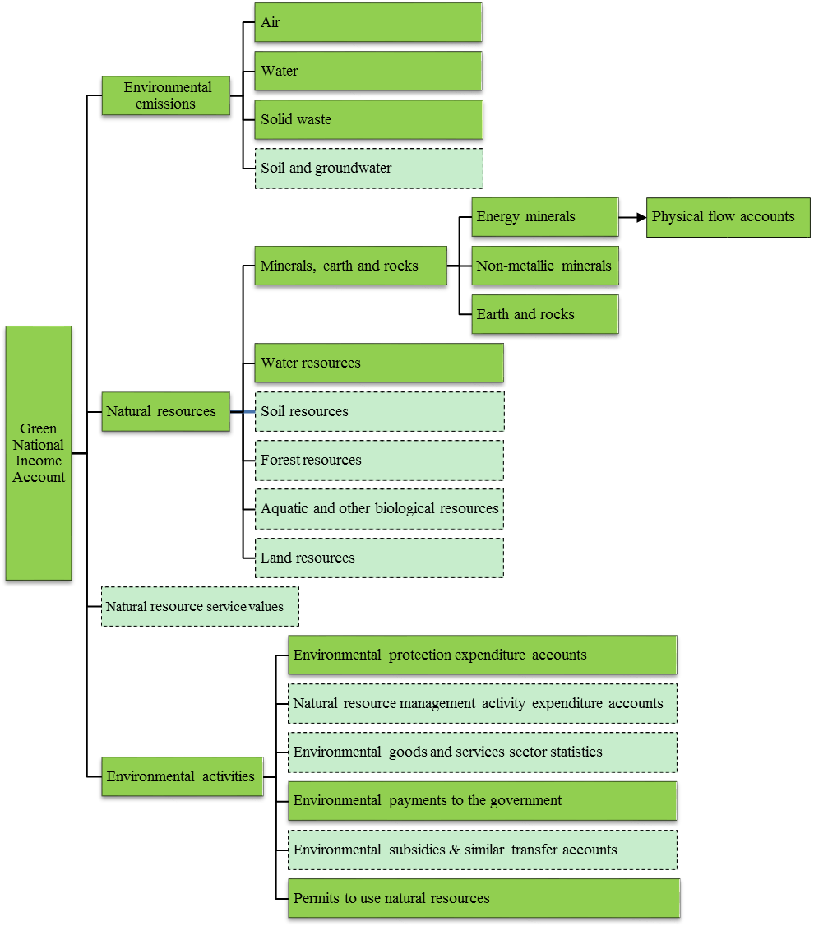
Physical asset accounts
Depletion accounts
Physical flow accounts
Emission accounts
Quality accounts
Degradation accounts
Note: The dotted boxes in the figure refer to the categories which have not yet been compiled.

